Web Programming Final Project

Concept

Booking system

Options

1. Concert
2. Movie Theater
3. Restaurant (could be used as base case)
4. Stadiums

Pros and Cons

All the concepts are the same , the functionalities are the same. The base case could help us to work on more limited numbers and avoid overcomplicating of the project.

Suppositions

1. The system be developed using a restaurant as model.
2. The amount of tables should be limited.
3. The end user can access the booking system on the main page of the restaurant, then select a table, a date and a time.
4. User also needs to provide a name, and a form indicating all the information will be printed on screen as proof or reservation for the user.
5. Internally, a list of all tables selected should be presented on a list (saves as array) to the restaurant users.
6. Another suggestion, use a small Italian restaurant, and create the whole image. A whole marketing concept.
7. Tables can be only booked for a maximum of 2 hours. The final user can search for specific times during the day and see if a table is available.
8. Working hours Tuesday -Thursday 11 am - 10 pm. Friday - Sunday 11 am - 12 md. Mondays closed.
9. The system will not contemplate information regarding employees, service, menu, delivery.
10. The main goal of the system is to provide visual information on reservations and a proof for the user, also, a reference of booking tables for the restaurant.
11. Customer indicate number of people.
12. All tables have enough space to accommodate customers with special needs.
13. Number of tables have been reduced to 20 to comply with COVID Social distancing (reduced from 40).
14. No dietary restriction, all customers know what to expect. We can include that in the menu.
15. Present the time restrictions on the main interface.

Conditions indicated (Professor)

1. Include concepts seen in class.
2. As far as now,
3. Arrays and their methods.
4. Objects (object table can contain 4 people, can be occupied from 1 - 4 people). These should contain methods and those functions.
   1. Book_table().
   2. Occupied_table().
   3. Release_table()
5. HTML, CSS and JS should be included in the project. That means a graphic representation should be made.
   1. Suggestions
      1. Tables represented as squares for the final user, and they change of color when selected for reservation.
      2. From the point of view of the restaurant user, all booked tables should be displaying change of color, number of occupants, date and time of reservation.
      3. Final proof of reservation presented as a ticket to print.
6. We need to include functions,
   1. at least one arrow function.
   2. Use function inside another function (nested functions)
   3. Callback
7. Hoisting for global execution
8. Objects
   1. Reusability. Objects should be reusable
   2. Use nested functions inside an object to define properties.

let Student = {

  FirstName: 'Amelie',

  LastName: 'Jones',

  FullName: function() { return (this.FirstName + ' ' + this.LastName) }

}

3.Play with function scope (this from object and this from global)

* 1. Use assign() to update the object information
  2. Properties concatenation for calling objects inside objects

1. Arrays
2. To work with arrays, include all the object Tables as part of an array to organize them, or the array will contain information about the time.
3. Apply the methods, slice can be used to replace a cancelled reservation, both free the time slot or replace it with a new reservation.
4. Promise to work over the written documents like example 07promise.

Convert to JSON object and use.

import fetch from 'node-fetch';

function SendGetRequest() {

setTimeout(function(){

let P = fetch("https://jsonplaceholder.typicode.com/todos");

P.then(Response => Response.json())

.then(Response => console.log(Response))

}, 3000);

};

function Greeting(){

console.log("Hello today...");

}

SendGetRequest();

Greeting();

1st meeting

1. All look for booking pages, get all the information we can, obsess requirements and try to fund functionality.
2. We can start imagining the image and marketing stuff to place on the website.

2nd meeting

Frank’s example

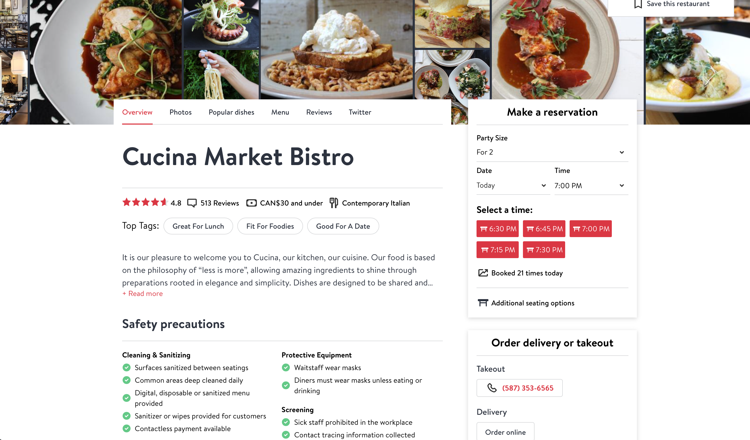

## Observations.

1. Reduced interface.
2. Allows the user to enter a preferred data
3. System Shows all tables available. (This prevents the system to try to accommodate the users, instead the users need to accept available options.
   1. Times available will be graphically represented based on available tables (if there are tables free at 6:30, they will be presented.
   2. Do we want to present distribution? I haven’t seen anything like it. If we proceed, instead of the red squares we can move the user to a new page, or this one, and present the 20 tables, red for those occupied and green for those free, following the color palette of the place.
4. Objects
   1. Customer
      1. GetName()
      2. SetName()
      3. SetPartySize()
      4. GetPartySize()./ be defined as object inside object to use property contatenation.
      5. MakeReservation()
      6. CancelReservation()
   2. Table
      1. SetCustomer(). //association with Customer object.
      2. GetCustomer()
      3. GetTime()
      4. SetTime()
      5. ShowAvailable()
      6. GetLocation()
      7. SetLocation()
      8. SetAdditionalSeatingOptions(). //Children seats, wheelchairs, walkers for elders.
      9. GetAdditionalSeatingOptions()
   3. Service //management
      1. GeTables()
      2. SetTables()
      3. MakeReservation()in case customer sends an email or calls.
      4. CancelReservation()
   4. To avoid working with time objects, Create an object that represents time, and the name will be a subdivision of 30 minutes.

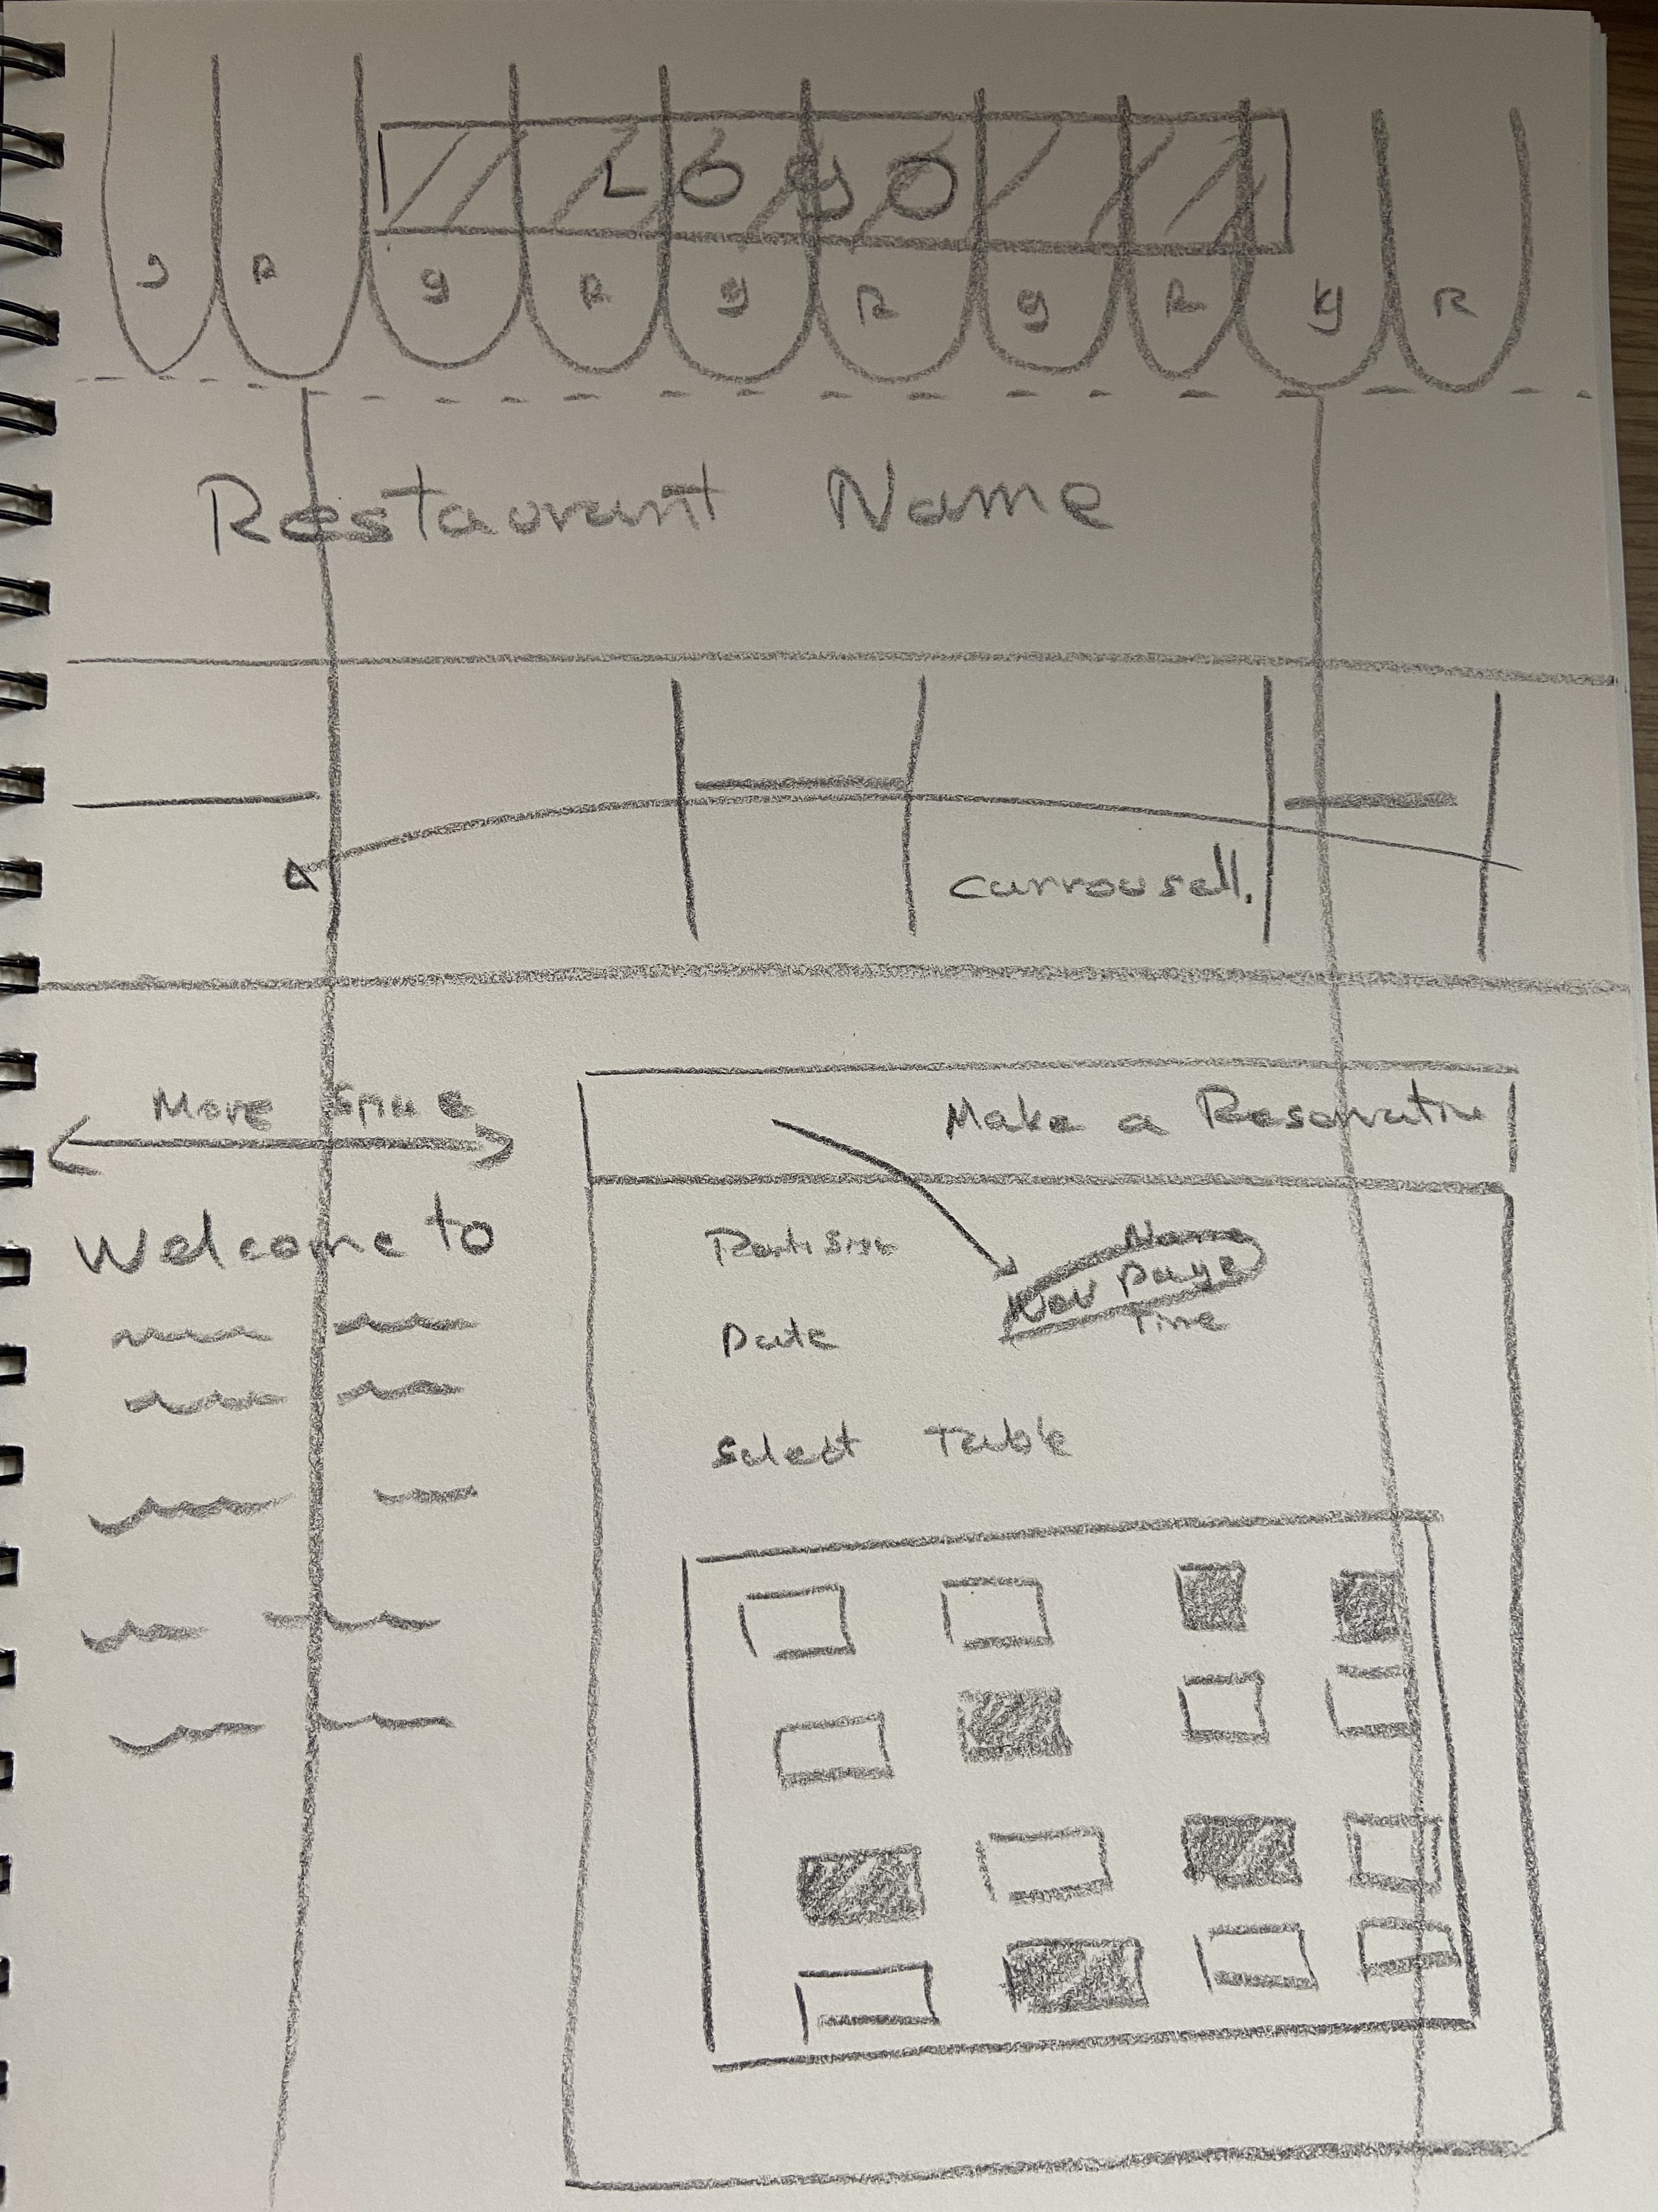

# Pedro

1) Mangement / Customer View

2) No need to seeing/arranging tables from the customer perspectives.

# Peter

Minimum buying.

Should determine what is the minimum requested by the professor.

# Colin

Functionalities:  
Book online or maybe by phone? (Useable by staff and customers?)  
Choose your table or random?  
Table or booth?  
Time Slots  
Order of choosing?  
Cancel or adjust your booking? Maybe give a code for such purposes or require login?  
Obtaining a name and number of guests for when they arrive?

Don't:  
Cluster people together, maybe have an algorithm to try and keep things spread out  
!!Unless of course they are choosing their locations  
  
Objects:  
Tables  
Groups  
Restaurant itself  
Bar area?

Restriction 1 – 8 hours bookings.

Frank UML gadgets

Object identification and interaction

Please review my suggestion to work with time.

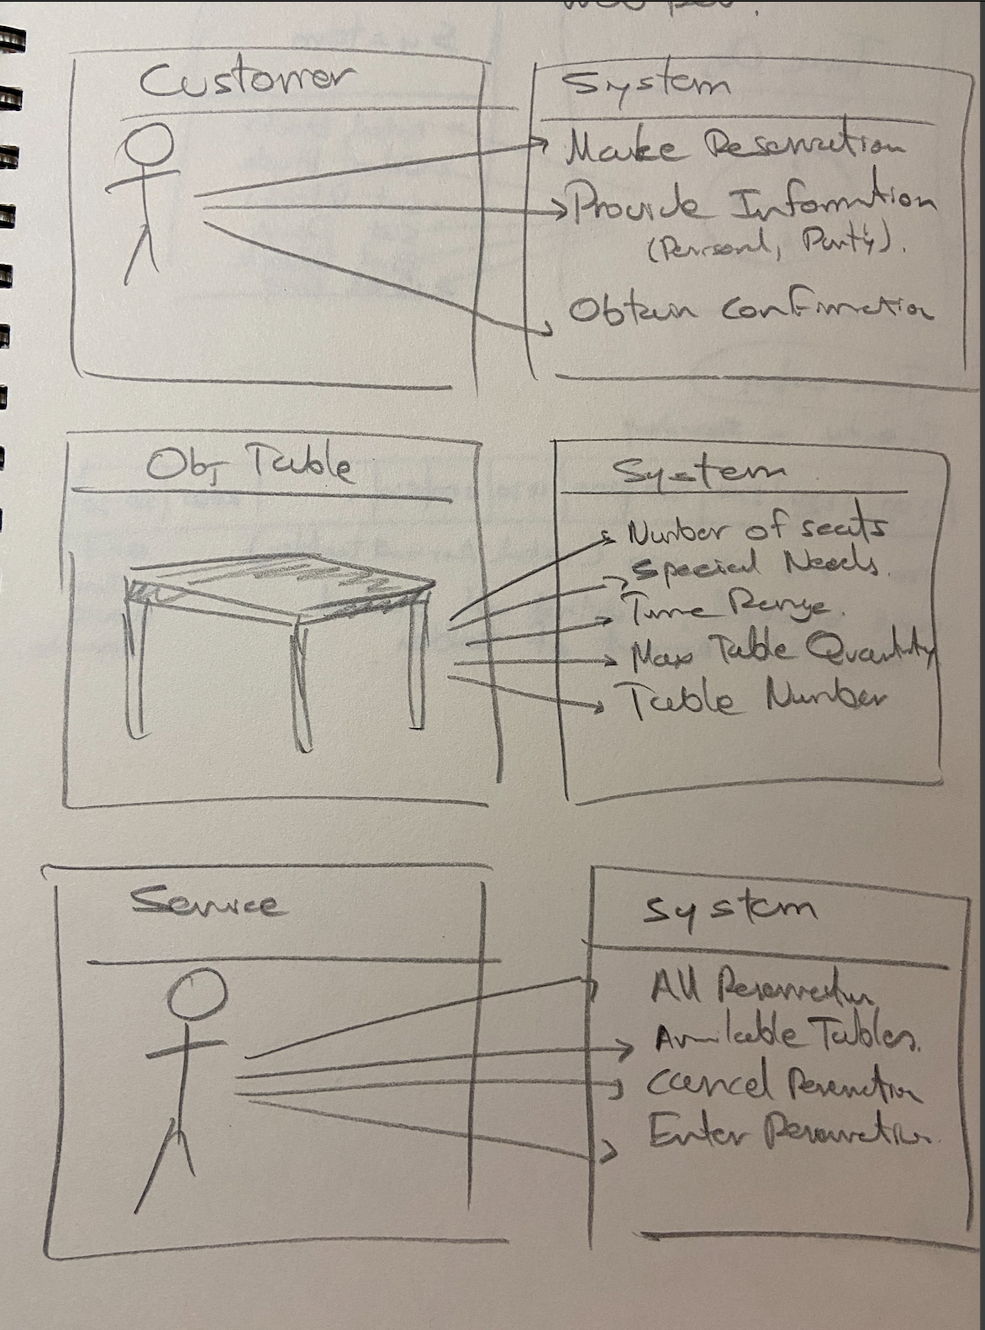

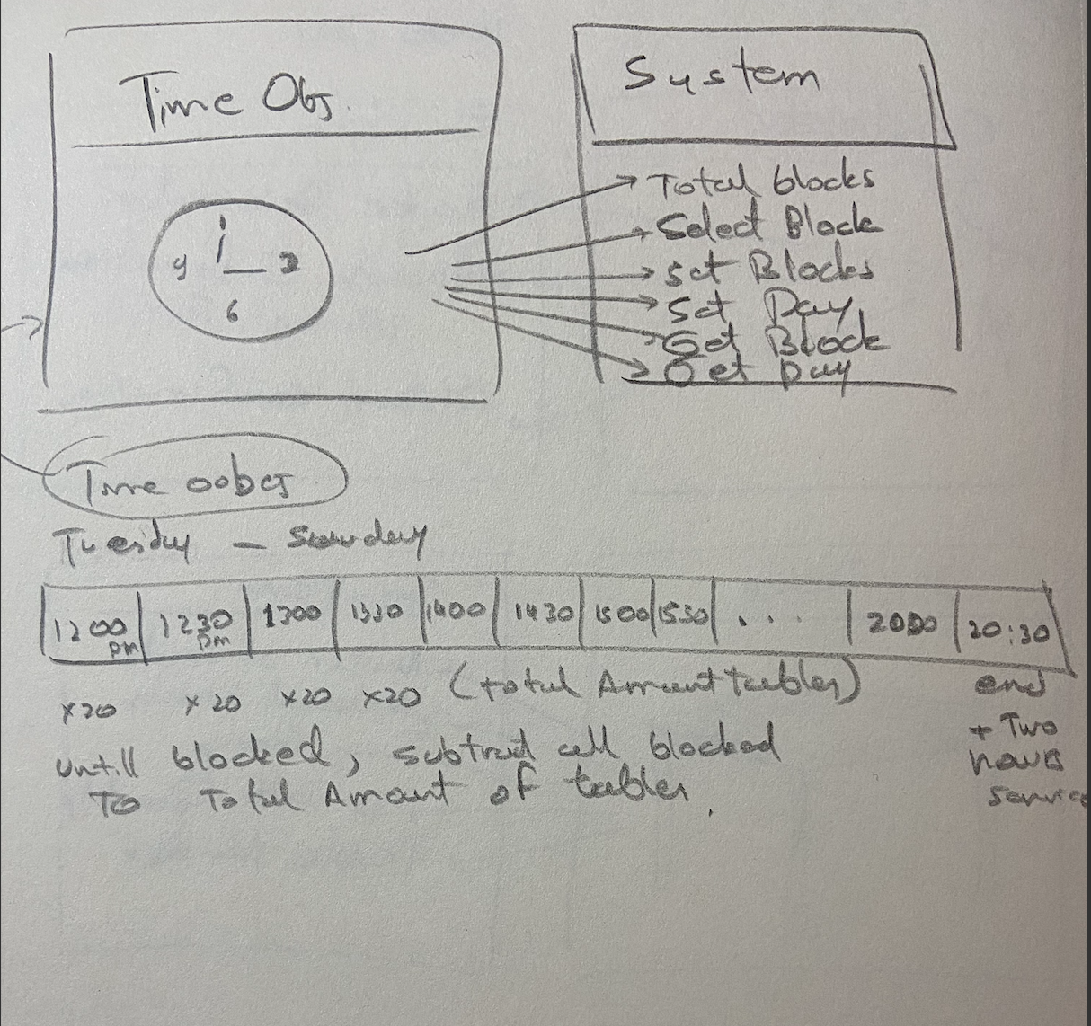

Dates

<https://www.w3schools.com/Js/js_dates.asp>

To print the reservation proof

<h2>The window.print() Method</h2>

<p>Click the button to print the current page.</p>

<button onclick="window.print()">Print this page</button>

This element was presented by the Professor. JSON format, I can extract this using API.

